Web Design and Development

4COSC011W

Report

Author:

Student ID:

2018392

(w1761777)

Group Number: 8

Student Role: 1

Link(s) to WebSite

URL:

1. Introduction 4

2. Technical Discussion 5

3. Discussion of UI and application of UX principles 9

3.1 Information architecture 10

a. Design 10

b. Code to achieve good Information architecture 10

3.2 Colour balance/composition/graphics/consistency 10

a. Design 10

b. Code to achieve good colour balance & ensure consistency 10

c. Colour contrast test results 13

3.3 Typography / consistency 14

a. Design 14

b. Code to achieve good typography / consistency 14

3.4 Gestalt principles grouping 15

3.5 Accessibility (graphics/forms) 16

a. Graphical elements - Design/Code 16

16

16

16

b. Form completion - Design/Code 16

3.6 Error prevention and recovery 17

a. Design 17

b. Code to address error prevention and recovery 18

4 Janet 20

5 Conclusions 21

References 22

Appendices 22

Appendix A: Code 22

Appendix B: Screenshots 30

Appendix C: Individual Statement 33

# Introduction

Sri Lankan Tourism

Student 1 :

* Presentation Page
* Shop page/ Buying Products page
* Font Size Change

Student 2 :

* Main Page
* Feedback Form

Student 3 :

* Quiz
* Student Details Page

Student 4 :

* Site Map
* Diagrams

All Students:

* External CSS
* CV
* Anchors
* Logo/Page Editor
* Additional Interactivity

We choose “Tourism” for our topic and this topic we select Sri Lankan Tourism. Because of that we created a creative web site as a team.

# Technical Discussion

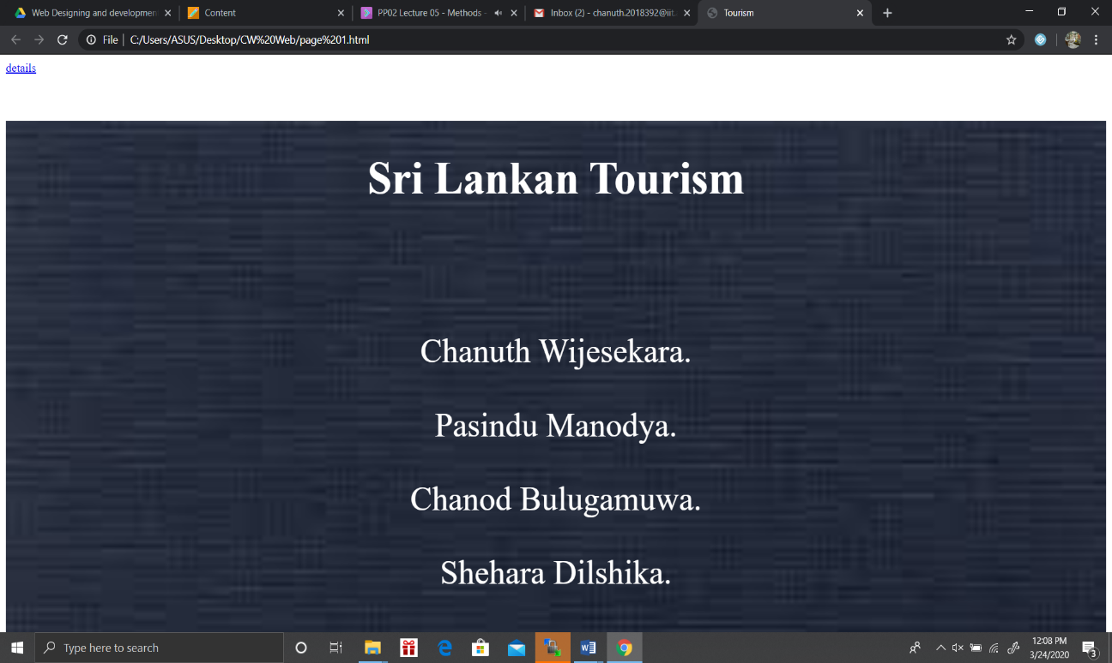

Here I created a simple presentation page with blue background image. Text is in placed on a little bit darker background and Text colour is white and it perfectly fit to the background.

Next I have created a Nav bar to access the other web pages.

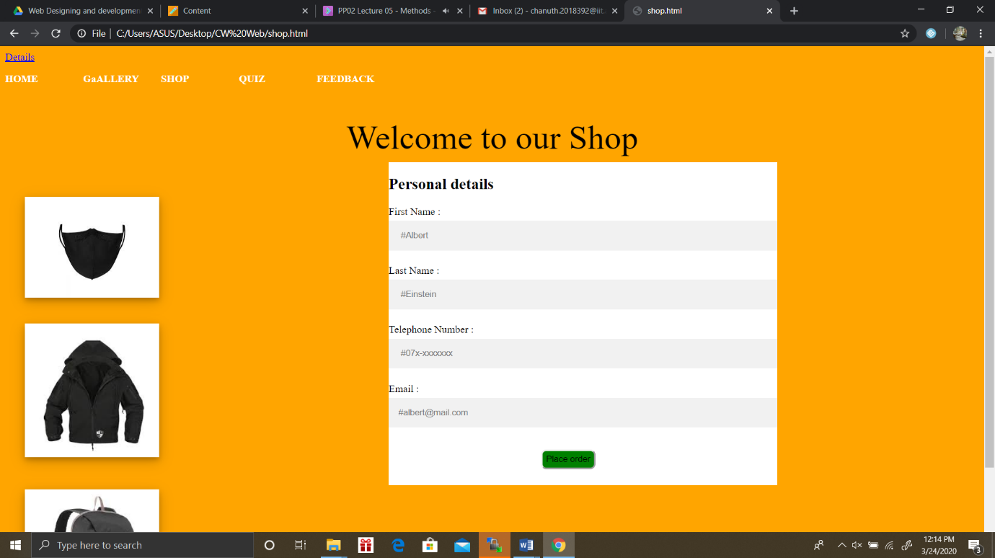

Customer can access the every navigation items to travel through the whole website.

Colour : Orange.

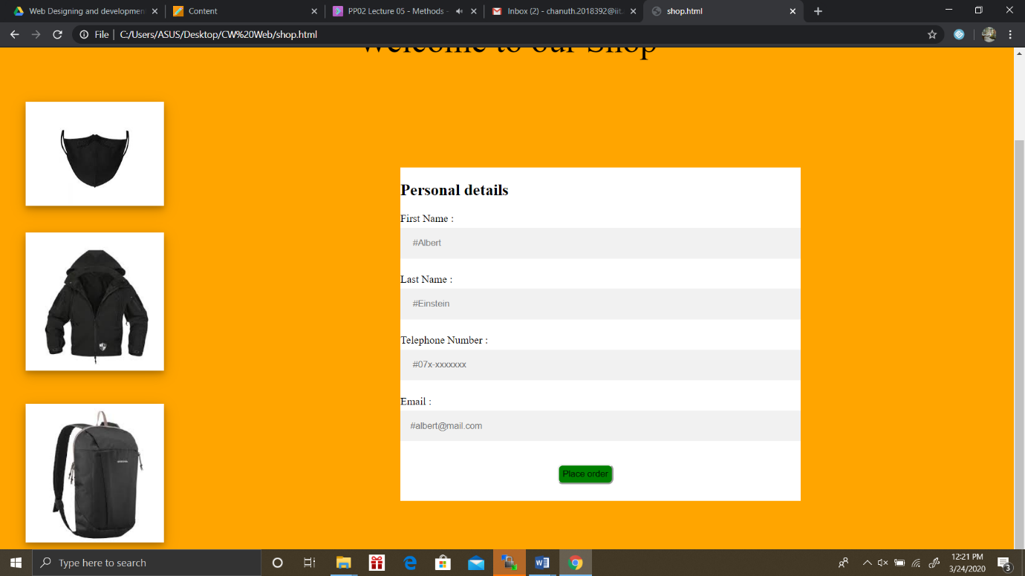

Here it is the Shop items customer can purchase .

Colour: Orange.

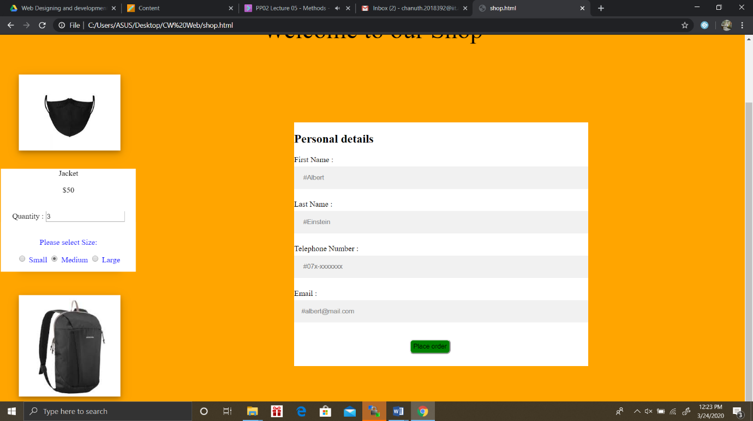Here customer should choose the number of items and customer can purchase all items with a fair price.

Example :

3 Jacket Ordered at a price of $ 50 each.

After customer purchasing the items customer should give his details to our website to verify him.

Colour: Orange.

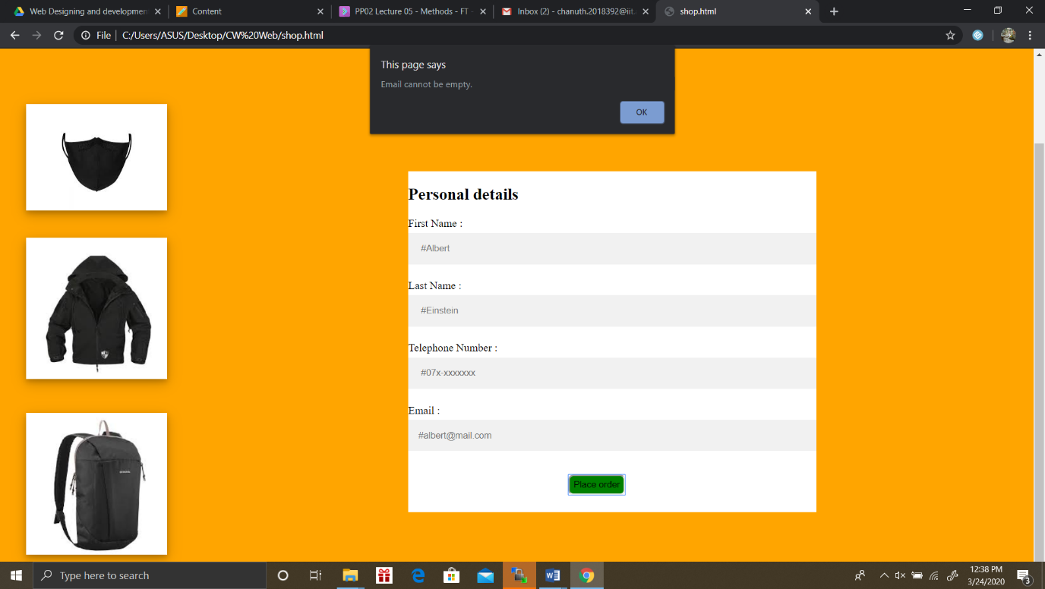 Button Colour: Green .

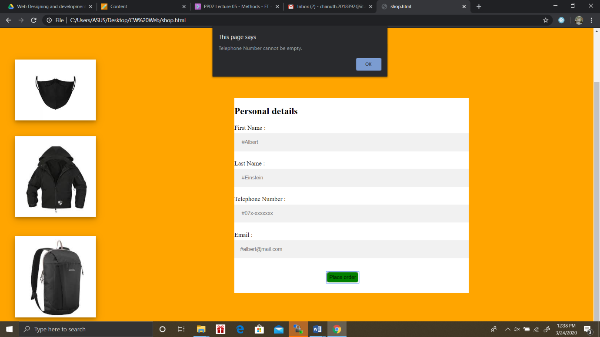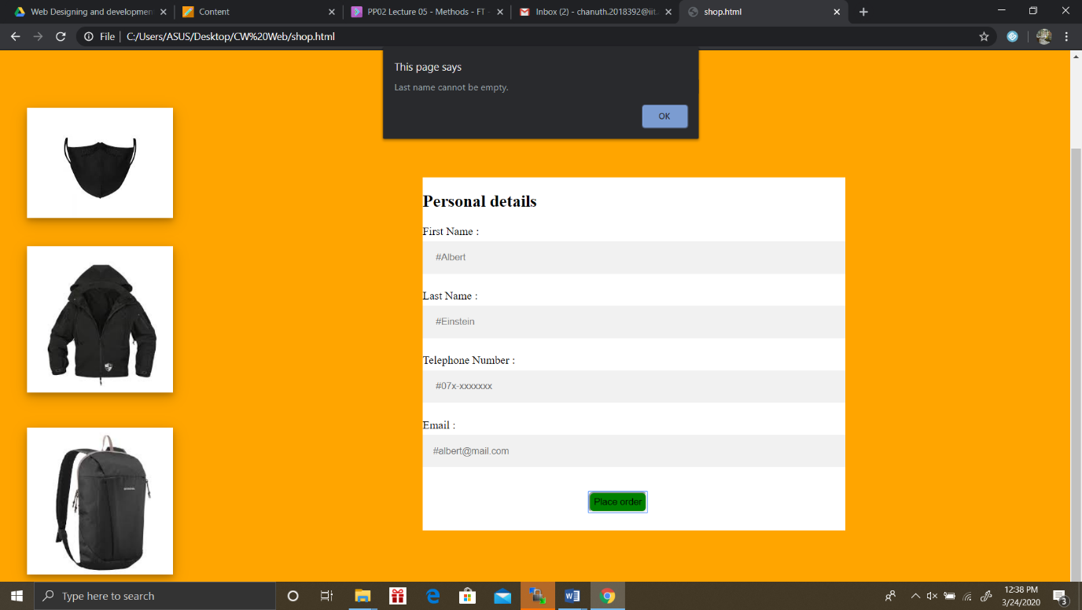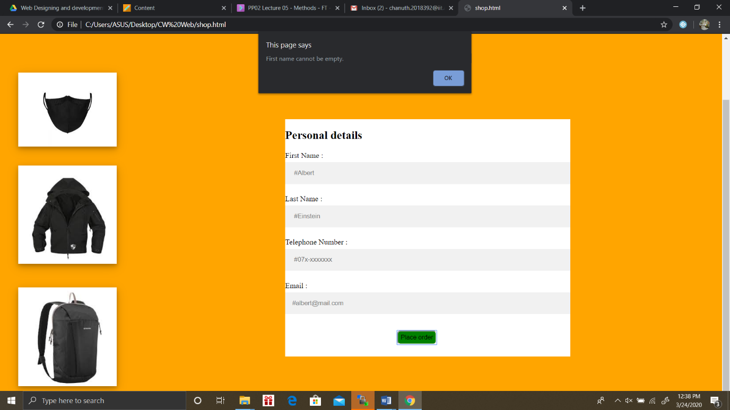

Here Customer purchasing items and needs to fill this form otherwise he/she gets a warning message as “First Name Cannot be empty”. Customer needs to give his all details to our website otherwise he can’t purchase items.

Customer getting these error as mentioned above.

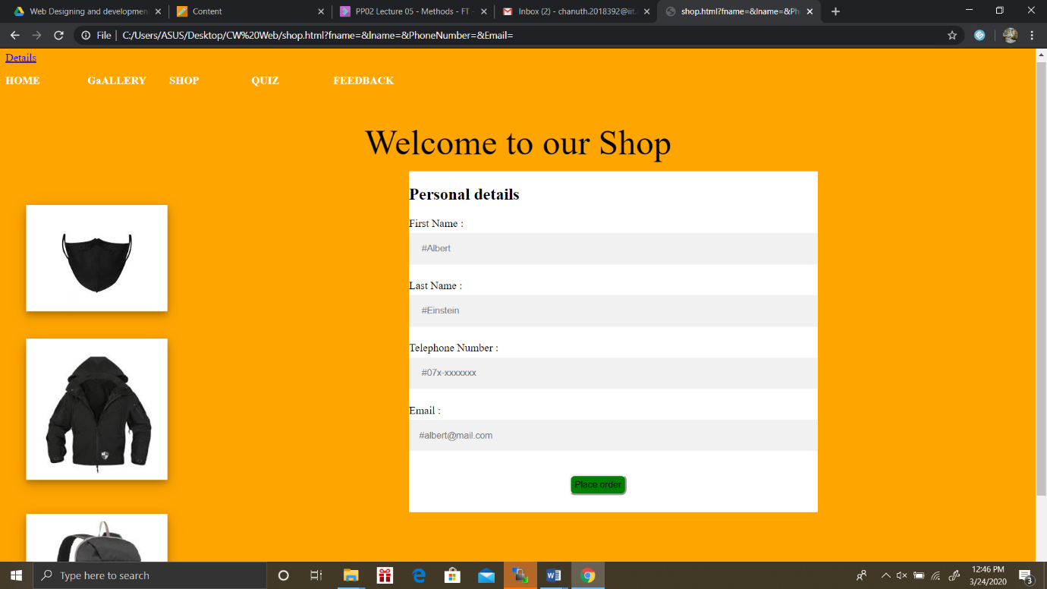

This is the Whole shopping cart web page and after customer purchase items customer received a bill mentioning what he purchased and what’s the cost of each product and finally he getting a total bill of what he purchased with item names.

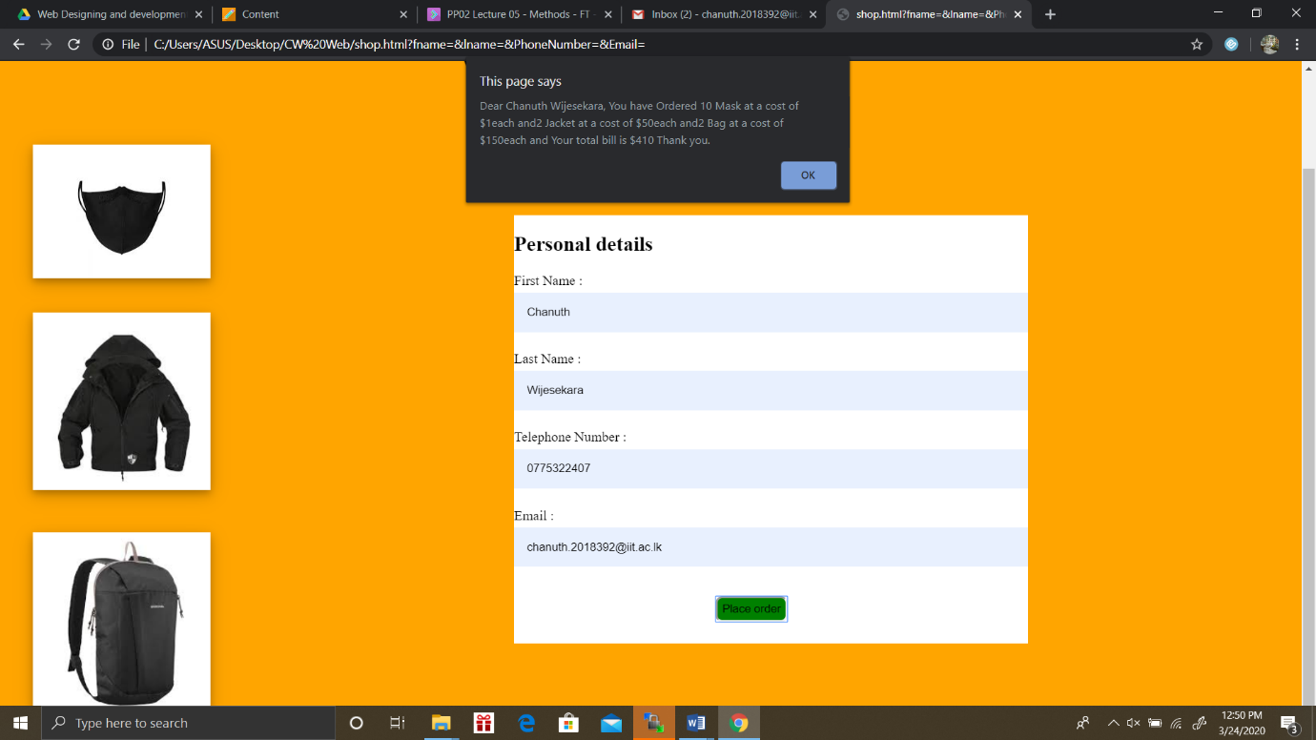

For the popup boxes I used alert box because it is simple and its perfectly fit our webpage.

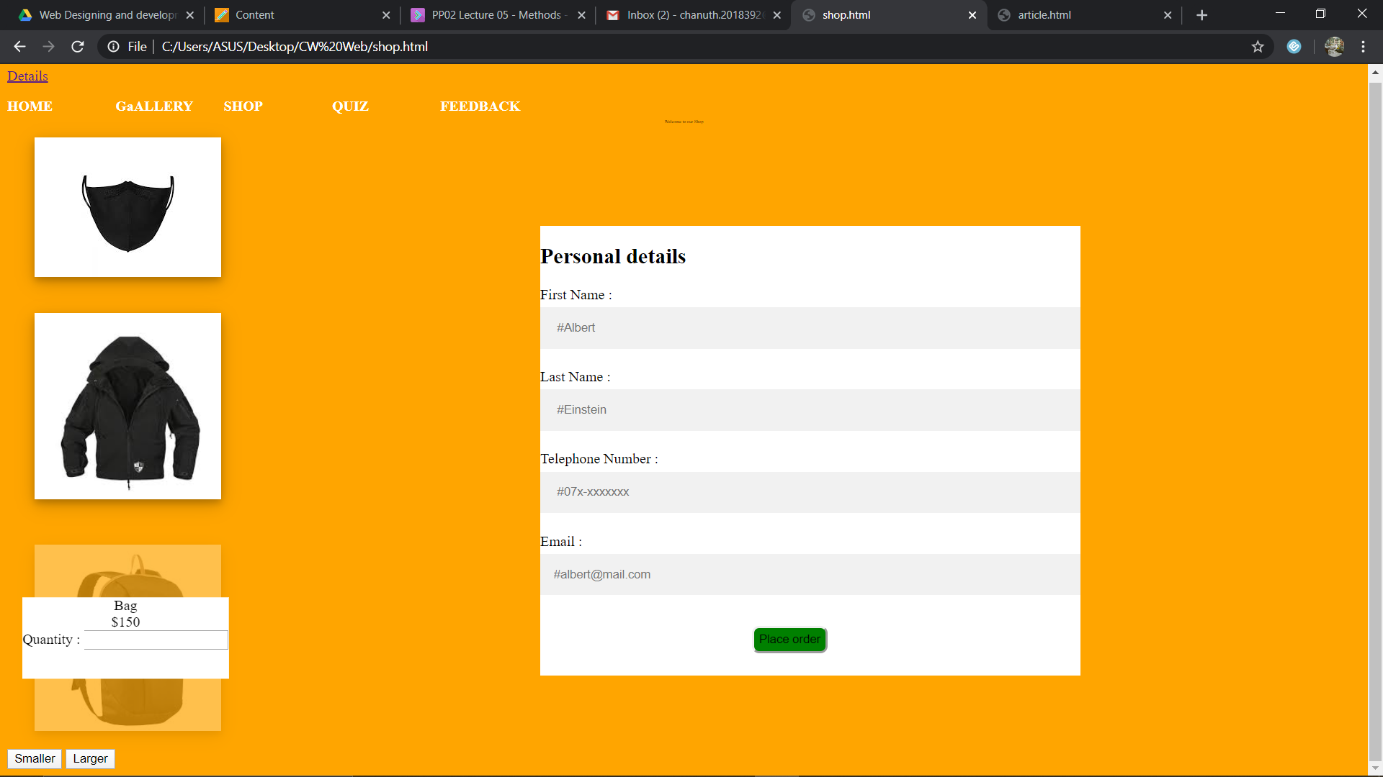

Customer press smaller button text getting smaller but customer press larger button it won’t work.

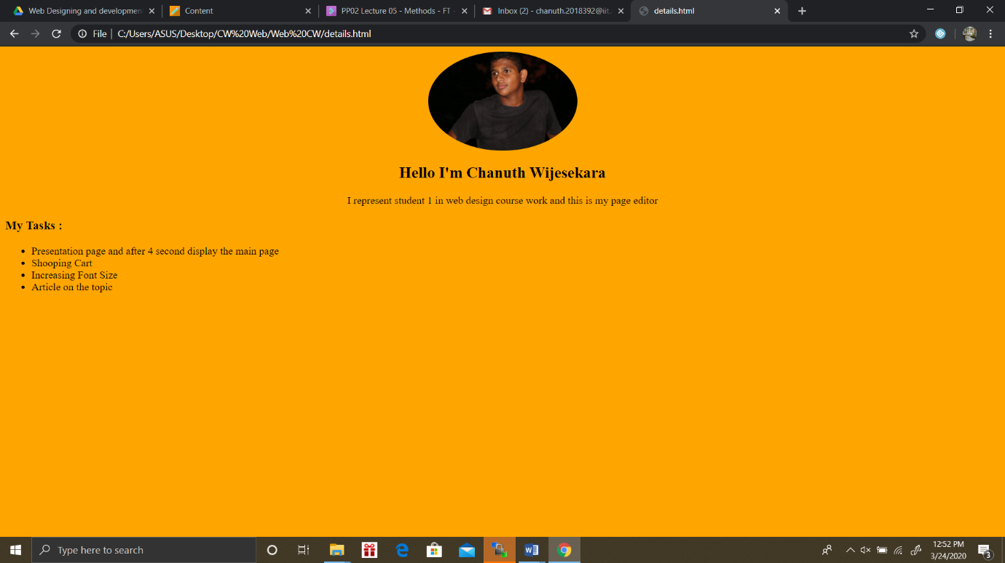

This is my other web page describing what I did on our website.

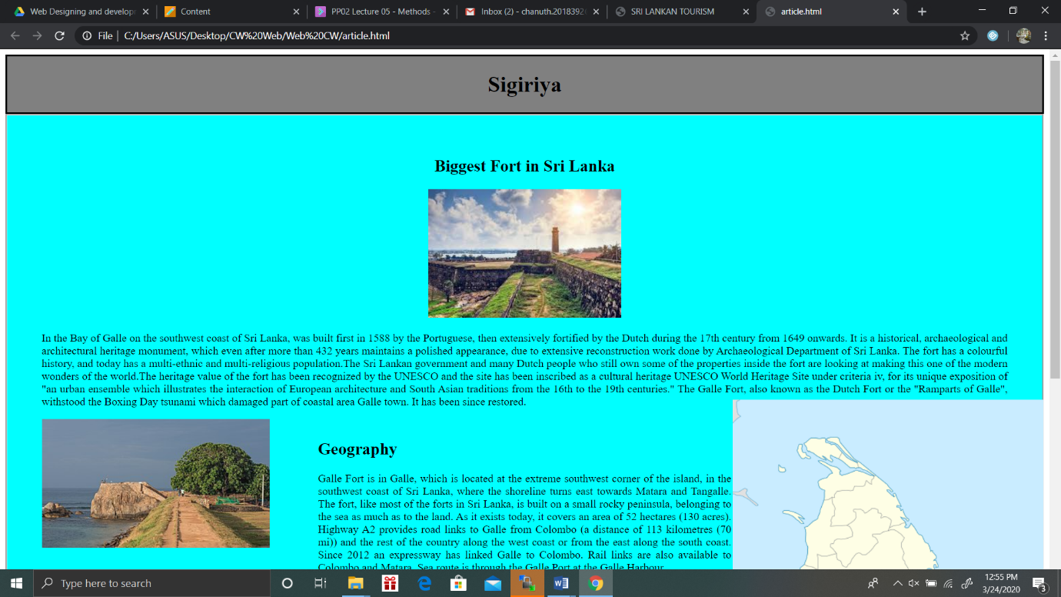

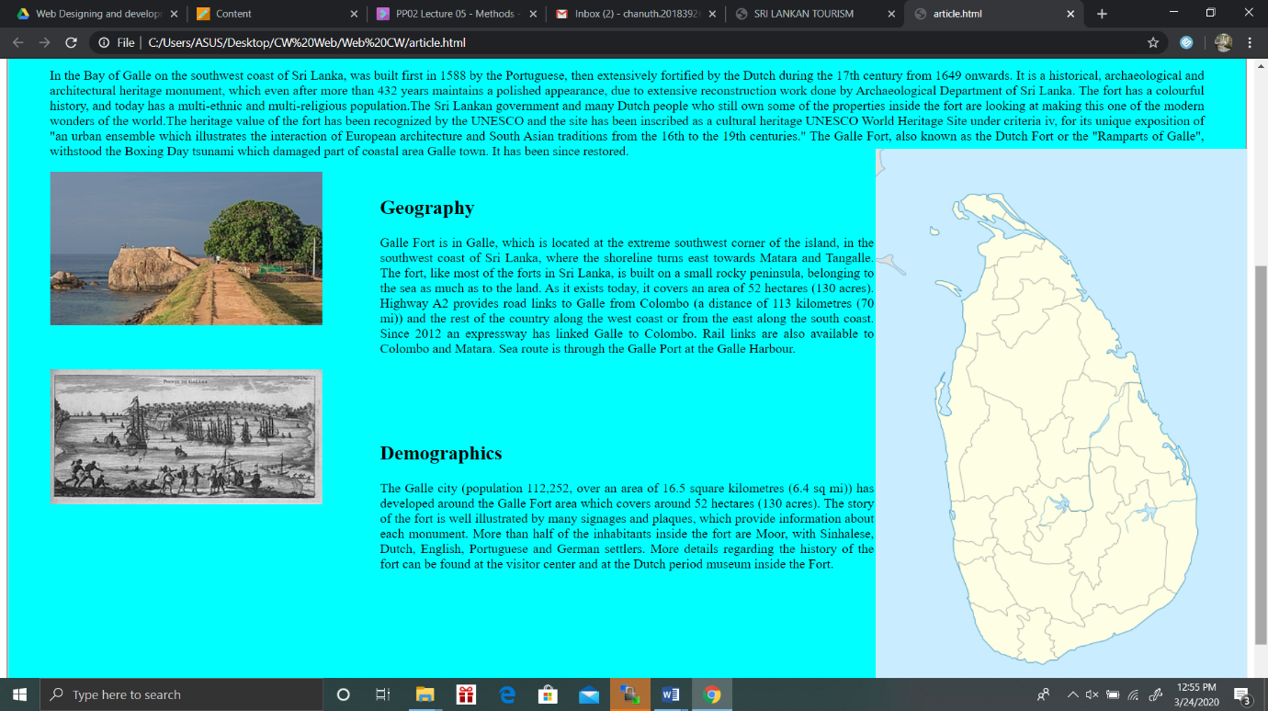

This is my final web page and it’s about Galle Fort and this is a small article about Galle Fort.

Colour: Aqua.

Border-Style: groove.**.**

# Discussion of UI and application of UX principles

I have applied UI and UX principles for my webpage. In my web page I used Orange and white as main colours because these colours user attractive colours and user friendly. I use text-alignment to make my web page more beautiful and for the article page used border-styles to make page visible. Main border-styles are “groove and solid” so these borders make web page more attractive. And also when customer selecting an item customer getting a overlay including name price and quantity. I chose most beautiful backgrounds for my web page to make it user friendly web page. At the top of the every page on website each student detail page display with their tasks.

## 3.1 Information architecture

### a. Design

In information architecture we used navigation bar to access the web site easily and customer can travel through the whole website without getting any problems.

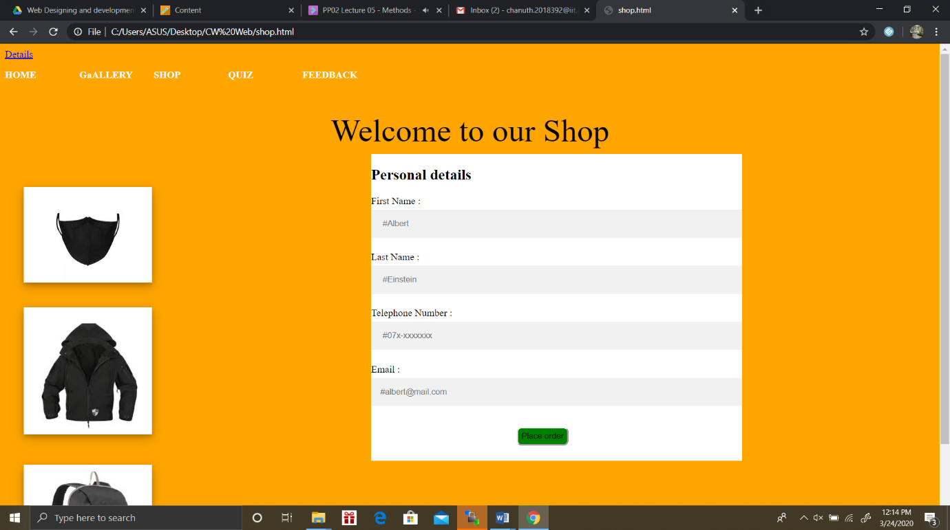

Navigation bar is very simple and user friendly. On a one simple click user can access the Home page , Gallery , Quiz and Feedback.

### b. Code to achieve good Information architecture

## 3.2 Colour balance/composition/graphics/consistency

### a. Design

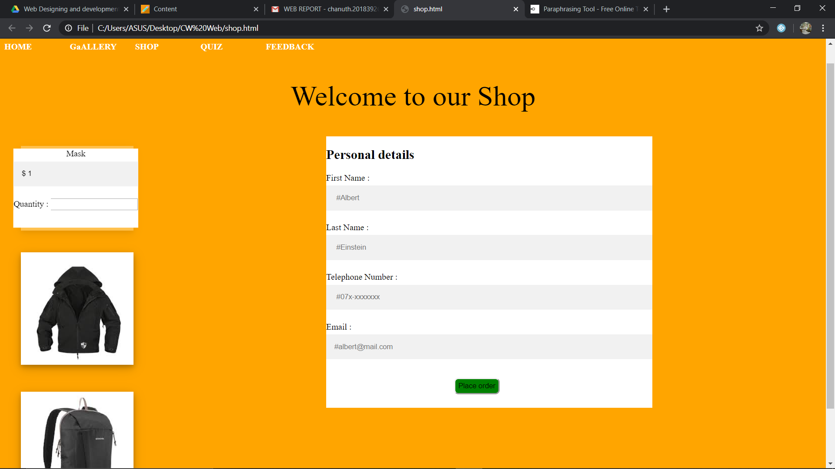

Our website we used the colours, Orange and Black are the main colours out of them green colour is used for buttons to get user attraction. Our site turns into a respectable brand for clients at their initial introduction. With those hues we can make certain highlights stand apart to the client.

### b. Code to achieve good colour balance & ensure consistency

#body{

background-color: orange;

}

#greet{

text-align: center;

color: black;

font-size: 52px

.corona {

box-shadow: 0 4px 8px 0 rgba(0, 0, 0, 0.2), 0 6px 20px 0 rgba(0, 0, 0, 0.19);

opacity: 1;

display: block;

width: 50%;

height: auto;

transition: .5s ease;

backface-visibility: hidden;

}

.middle {

background-color: white;

transition: .5s ease;

opacity: 0;

position: absolute;

top: 50%;

left: 17.5%;

transform: translate(-50%, -50%);

-ms-transform: translate(-50%, -50%);

text-align: center;

}

.container:hover .corona {

opacity: 0.3;

}

.container:hover .middle {

opacity: 1;

}

.btn {

background-color: white;

color: blue;

font-size: 16px;

padding: 16px 32px;

}

.container1 {

padding: 30px 30px;

position: relative;

width: 50%;

}

.jacket {

box-shadow: 0 4px 8px 0 rgba(0, 0, 0, 0.2), 0 6px 20px 0 rgba(0, 0, 0, 0.19);

opacity: 1;

display: block;

width: 100%;

height: auto;

transition: .5s ease;

backface-visibility: hidden;

}

.middle1 {

background-color: white;

transition: .5s ease;

opacity: 0;

position: absolute;

top: 50%;

left: 17.5%;

transform: translate(-50%, -50%);

-ms-transform: translate(-50%, -50%);

text-align: center;

}

.btn1 {

background-color: white;

color: blue;

font-size: 16px;

padding: 16px 32px;

}

.bags {

box-shadow: 0 4px 8px 0 rgba(0, 0, 0, 0.2), 0 6px 20px 0 rgba(0, 0, 0, 0.19);

opacity: 1;

display: block;

width: 100%;

height: auto;

transition: .5s ease;

backface-visibility: hidden;

}

.middle2 {

background-color: white;

transition: .5s ease;

opacity: 0;

position: absolute;

top: 50%;

left: 17.5%;

transform: translate(-50%, -50%);

-ms-transform: translate(-50%, -50%);

text-align: center;

}

.btn2 {

background-color: white;

font-size: 16px;

padding: 16px 32px;

}

.details{

background-color: white;

position: fixed;

top: 180px;

left: 600px;

width: 600px;

height:500px;

}

*{

box-sizing: border-box;

}

input[type=text] {

width: 100%;

padding: 15px;

margin: 5px 0 22px 0;

display: inline-block;

border: none;

background: #f1f1f1;

}

#order{

position: fixed;

height: 30px;

top: 625px;

right: 600px;

background-color: green;

border-radius: 8px;

}

### c. Colour contrast test results

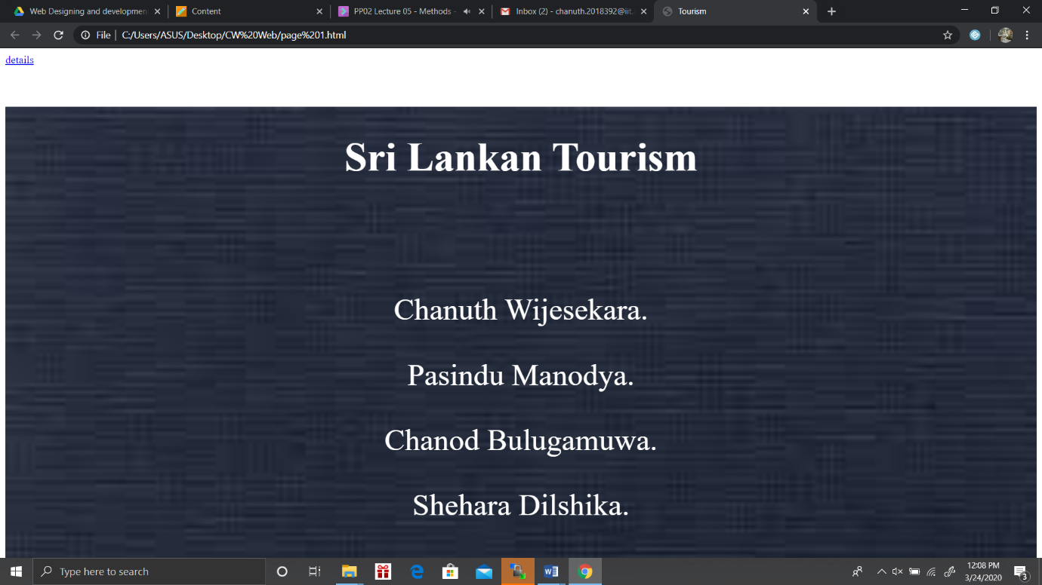



## Typography / consistency

### a. Design

I used different font sizes out of them for the presentation page I used 60px for the Header and 45px to the name and I set the text colour to white for the header and names it displayed bold letters.

And also for the Shopping cart page for items names font-size is 16px and other fonts are normal size.

### b. Code to achieve good typography / consistency

#Header {

font-size:60px;

color: white;

font-weight: bold;

font-family:italic;

padding: 40px;

text-align:center;

background-size: cover;

}

#names {

font-size:45px;

font-weight: 600px;

color: white;

padding: 20px;

}

.btn2 {

background-color: white;

font-size: 16px;

padding: 16px 32px;

}

## Gestalt principles grouping

In the shopping cart page we used these rectangular boxes to our page. Because of that customer can easily recognize the page with the background.



We mainly used hover effect in our website. With that hover effect user can easily see which option he or she is in. For the item table we use overlay effect for increase user readability and give good energy to user and the webpage.

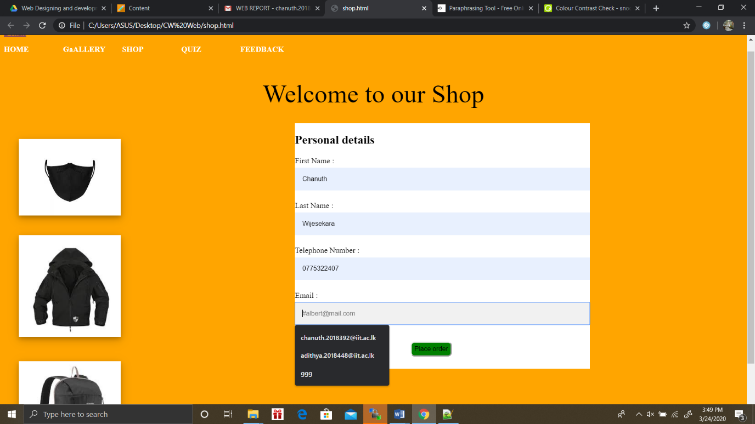

## 3.5 Accessibility (graphics/forms)

### a. Graphical elements - Design/Code

After filling the form user can see textfields are getting powder blue,. And also mouse pointer is on the item item get little bit dissapear and show the image as a shadow.



### 

### 

### 

### b. Form completion - Design/Code

<div class ="details">

<!-- Creating a form with unique name. -->

<form name="details" onsubmit="message()"><!-- onsubmit getting an popbox to warn empty fields. -->

<h2> Personal details </h2>

<label for="fname">First Name :</label><br>

<input type = "text" id = "fname" name ="fname" placeholder=" #Albert "><br>

<label for="lname">Last Name :</label><br>

<input type = "text" id = "lname" name ="lname" placeholder=" #Einstein "><br>

<label for="PhoneNumber">Telephone Number :</label><br>

<input type = "text" id = "PhoneNumber" name ="PhoneNumber" placeholder=" #07x-xxxxxxx"><br>

<label for="Email">Email :</label><br>

<input type = "text" id = "Email" name ="Email" placeholder="#albert@mail.com"><br>

<input id = "order" type="submit" value ="Place order" onclick ="validate();">

<!-- onclick getting the customer name and prices of the items and total bill. -->

</form>

</div>

<div> Tags are used to uniquely identify each details easily and give ID’s to get that details identically. In this page developer can easily understand the code without getting any issues.

## 3.6 Error prevention and recovery

### a. Design

User forgot to enter his/her details in the form they get a warning message but that warning message not displayed in my website and I remake my javascript code several times and Finally I got the error massage. And I apply that theory to fix my errors. And also after user purchasing items his/her total bill is not displayed and I create a javascript code to give a popbox with their names , items and total price.

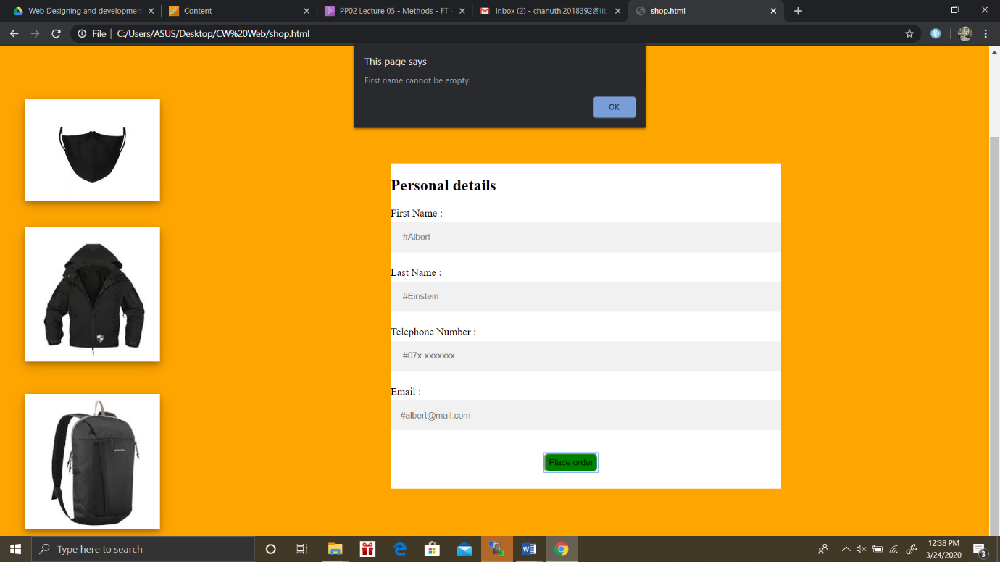

### b. Code to address error prevention and recovery

Javascript code:

Form Validation:

function validate(){

var fname = document.getElementById("fname").value;

var lname = document.getElementById("lname").value;

var number = document.getElementById("PhoneNumber").value;

var email = document.getElementById("Email").value;

if (fname == ""){

errMsg = "First name cannot be empty.";

alert(errMsg);

}

if (lname == ""){

errMsg = "Last name cannot be empty.";

alert(errMsg);

}

if (number == ""){

errMsg = "Telephone Number cannot be empty.";

alert(errMsg);

}

if (email == ""){

errMsg = "Email cannot be empty.";

alert(errMsg);

}

return result;

}

This is the bill:

function message(){

var mask = document.getElementById("mask").innerHTML;

var jacket = document.getElementById("jacket").innerHTML;

var bag = document.getElementById("bag").innerHTML;

var price = 1;

var price1 = 50;

var price2 = 150;

var quantity = document.getElementById("quantity").value;

var quantity1 = document.getElementById("quantity1").value;

var quantity2 = document.getElementById("quantity2").value;

var fname = document.getElementById("fname").value;

var lname = document.getElementById("lname").value;

var total = price * quantity + price1 * quantity1 + price2 * quantity2;

if (quantity1 == ""){

if (quantity2 == ""){

alert("Dear " + fname +" " + lname +", You have Ordered " + quantity + mask + "at a cost of $" + price + "each and Your total bill is $" + total + "Thank you.");

}

}

if(quantity == ""){

if (quantity2 == ""){

alert("Dear " + fname +" " + lname +", You have Ordered " + quantity1 + jacket + "at a cost of $" + price1 + "each and Your total bill is $" + total + "Thank you.");

}

}

if(quantity == ""){

if (quantity1 == ""){

alert("Dear " + fname +" " + lname +", You have Ordered " + quantity2 + bag + "at a cost of $" + price2 + "each and Your total bill is $" + total + "Thank you.");

}

}

else{

alert("Dear " + fname +" " + lname +", You have Ordered " + quantity + mask + "at a cost of $" + price + "each and" + quantity1 + jacket + "at a cost of $" + price1 + "each and" + quantity2 + bag + "at a cost of $"+ price2 + "each and Your total bill is $" + total + " Thank you.");

}

return result;

}

# Janet

We have added copyrights to our web site and anyone cannot change our web site. Top header of every page attached a Detail sheet to who created the page and his task by clicking that you can see it.

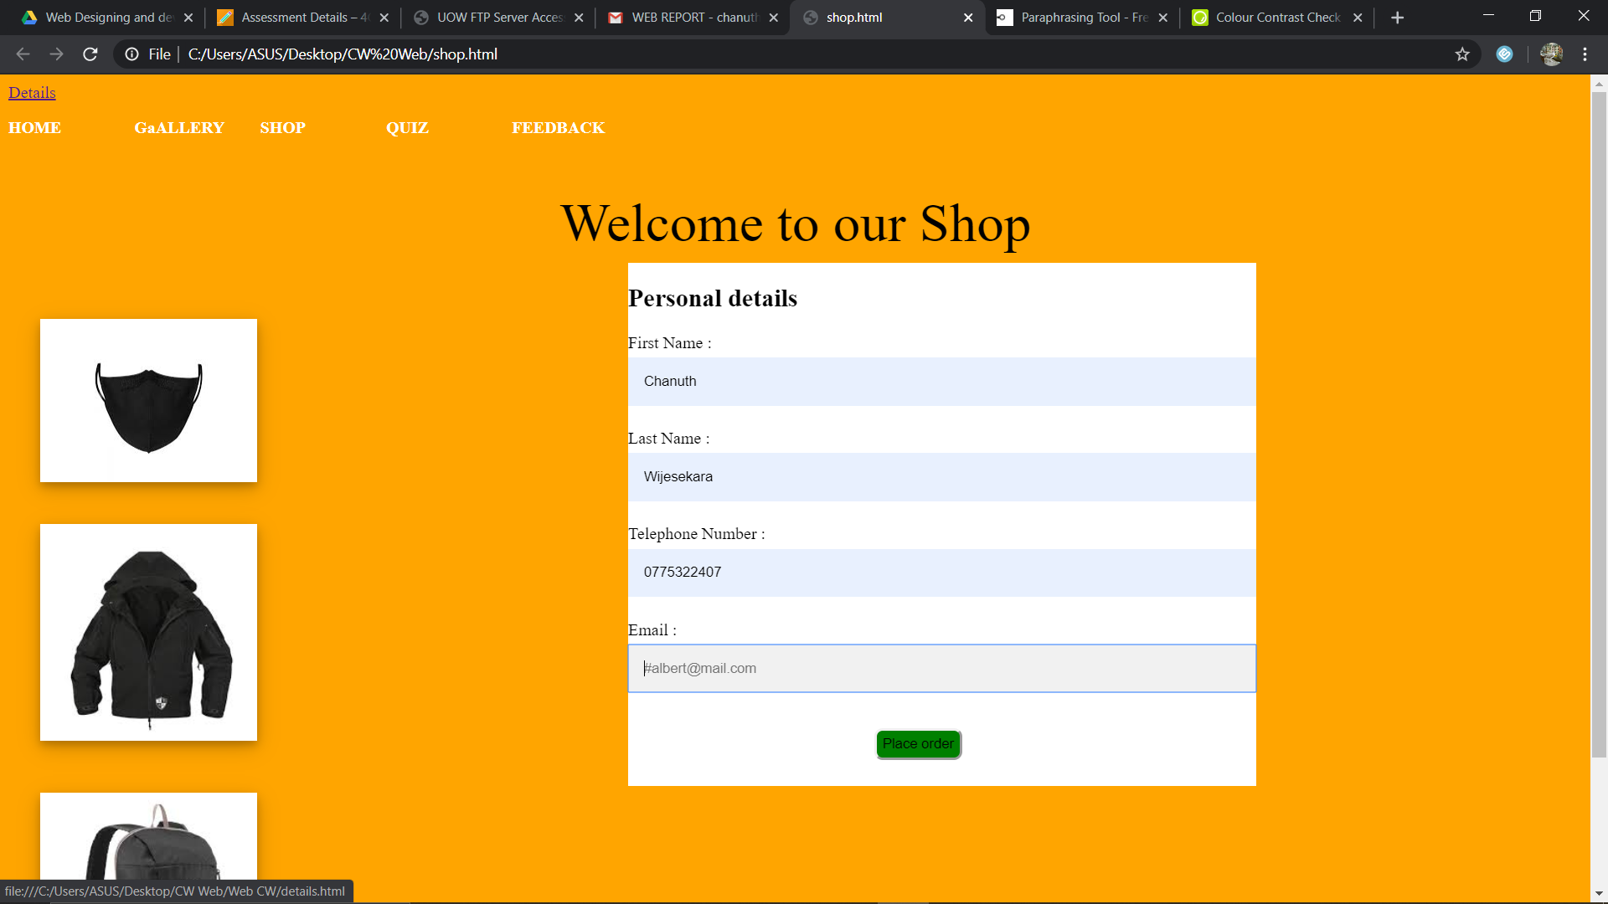

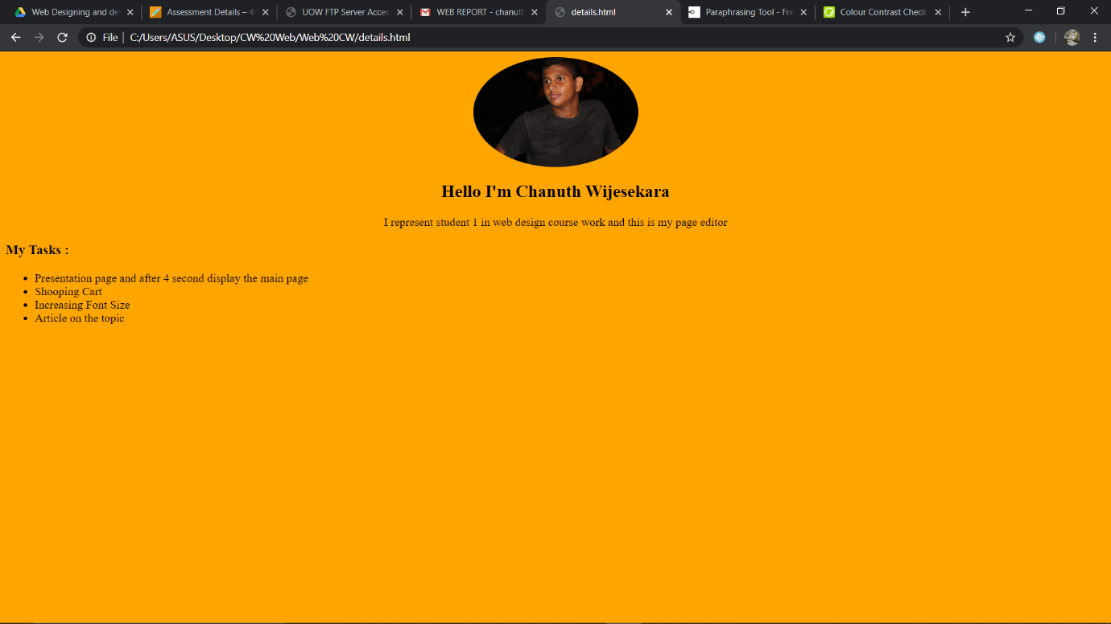

# Conclusions

Sri Lanka is Beautiful and best tourist attraction country in the world. We researched about Sri Lankan tourism and we came to a point to make our web page about tourism and we created it user friendly and user can easily understand the web site. We got a huge experience by creating this website. And also we learn how to solve problems and how to face the problems and how to get proper solutions for the problems is easier when we work as a team.

# References

<https://www.w3schools.com/html/default.asp>

<https://stackoverflow.com/>

# Appendices

## Appendix A: Code

Filename

Page1.html

Code

HTML Code:

<! DOCTYPE html>

<html>

<head>

<a href = "details.html">details</a>

<link rel="stylesheet" type="text/css" href="page 1.css">

<div class = "Fullpage">

<title>Tourism</title>

</head>

<body>

<div class="body">

<p id = "Header"> Sri Lankan Tourism</h1>

<center>

<div id ="names">

<p>Chanuth Wijesekara.</p>

<p>Pasindu Manodya.</p>

<p>Chanod Bulugamuwa.</p>

<p>Shehara Dilshika.</p>

<div>

</center>

<script>

setTimeout(function(){

window.location.href = 'mainpage1.html';

}, 4000);

</script>

</div>

</body>

</html>

CSS Code:

Page1.css

.Fullpage {

background-image:url("images.jfif");

min-height: 580px;

background-size: cover;

background-position: center;

background-repeat: no-repeat;

position: relative;

}

#Header {

font-size:60px;

color: white;

font-weight: bold;

font-family:italic;

padding: 40px;

text-align:center;

background-size: cover;

}

#names {

font-size:45px;

font-weight: 600px;

color: white;

padding: 20px;

}

File Name

Shop.html

Code

HTML Code:

<!DOCTYPE html>

<html>

<head>

<a href = "Web CW\details.html">Details</a>

<link rel="stylesheet" type="text/css" href="Web CW\CSS\Menu.css">

<script src="validate.js"></script>

</head>

<body id = "body">

<nav>

<div class="menu">

<a href="mainpage1.html">HOME</a>

<a href="#">GaALLERY</a>

<a href="shop.html">SHOP</a>

<a href="#">QUIZ</a>

<a href="ValidationForm1.html">FEEDBACK</a>

</div>

<!-- Getting each element with a unique name. -->

<div class = "size">

<p id = "greet">Welcome to our Shop</p>

<div class="container">

<img src="Web CW\Images\mask.jfif" alt="Avatar" class="corona" style="width:30%">

<div class="middle">

<!-- Creating labels for naming the items. -->

<label for="name" id = "mask"> Mask </label><br>

<input type = "text" id = "price1" value = "$ 1"><br>

<label for="quantity">Quantity :</label>

<input type="number" id="quantity" name="quantity">

<div class="btn"></div>

</div>

</div>

<div class="container1">

<!-- Adding images and gave a unique id to the picture. -->

<img src="Web CW\Images\jacket.jfif" alt="Jacket" class="jacket" style="width:30%">

<div class="middle1">

<!-- Creating labels for naming the items. -->

<label for="name" id = "jacket"> Jacket </label><br>

<p id = "price1"> $50 </p><br>

<label for="quantity">Quantity :</label>

<input type="number" id="quantity1" name="quantity">

<div class="btn1">

<!-- Creating the radio buttons to select size of the T-shirt . -->

<p>Please select Size:</p>

<input type="radio" id="small" name="size" value="small">

<label for="male">Small</label>

<input type="radio" id="medium" name="size" value="medium">

<label for="female">Medium</label>

<input type="radio" id="largs" name="size" value="large">

<label for="other">Large</label>

</div>

</div>

</div>

<div class="container2">

<img src="Web CW\Images\bags.jfif" alt="Jacket" class="bags" style="width:30%">

<div class="middle2">

<!-- Creating labels for naming the items. -->

<label for="name" id = "bag"> Bag </label><br>

<label for="price"> $150 </label><br>

<label for="quantity">Quantity :</label>

<input type="number" id="quantity2" name="quantity">

<div class="btn2">

</div>

</div>

</div>

<div class ="details">

<!-- Creating a form with unique name. -->

<form name="details" onsubmit="message()"><!-- onsubmit getting an popbox to warn empty fields. -->

<h2> Personal details </h2>

<label for="fname">First Name :</label><br>

<input type = "text" id = "fname" name ="fname" placeholder=" #Albert "><br>

<label for="lname">Last Name :</label><br>

<input type = "text" id = "lname" name ="lname" placeholder=" #Einstein "><br>

<label for="PhoneNumber">Telephone Number :</label><br>

<input type = "text" id = "PhoneNumber" name ="PhoneNumber" placeholder=" #07x-xxxxxxx"><br>

<label for="Email">Email :</label><br>

<input type = "text" id = "Email" name ="Email" placeholder="#albert@mail.com"><br>

<input id = "order" type="submit" value ="Place order" onclick ="validate();"> <!-- onclick getting the customer name and prices of the items and total bill. -->

</form>

</div>

<button id="button1" value="smaller" type="button" onclick="changeFontSize(this)">Smaller</button> <!-- onclick action font size getting smaller. -->

<button id="button2" vale="larger" type="button" onclick="changeFontSize(this)">Larger</button>

</div>

</body>

</html>

CSS Code:

Menu.css

#body{

background-color: orange;

}

#greet{

text-align: center;

color: black;

font-size: 52px;

}

nav> .menu> a{

padding-top: 15px;

}

nav>.menu>a:hover{

background-color: #000000;

color:#AAAAAA;

border-bottom:1px solid #ffffff;

}

.menu{

width: 40%;

display: flex;

justify-content:space-around;

}

.menu a{

width:25%;

text-decoration: none;

color: white;

font-weight: bold;

}

.container {

padding: 10px 30px;

position: relative;

width: 50%;

}

.corona {

box-shadow: 0 4px 8px 0 rgba(0, 0, 0, 0.2), 0 6px 20px 0 rgba(0, 0, 0, 0.19);

opacity: 1;

display: block;

width: 50%;

height: auto;

transition: .5s ease;

backface-visibility: hidden;

}

.middle {

background-color: white;

transition: .5s ease;

opacity: 0;

position: absolute;

top: 50%;

left: 17.5%;

transform: translate(-50%, -50%);

-ms-transform: translate(-50%, -50%);

text-align: center;

}

.container:hover .corona {

opacity: 0.3;

}

.container:hover .middle {

opacity: 1;

}

.btn {

background-color: white;

color: blue;

font-size: 16px;

padding: 16px 32px;

}

.container1 {

padding: 30px 30px;

position: relative;

width: 50%;

}

.jacket {

box-shadow: 0 4px 8px 0 rgba(0, 0, 0, 0.2), 0 6px 20px 0 rgba(0, 0, 0, 0.19);

opacity: 1;

display: block;

width: 100%;

height: auto;

transition: .5s ease;

backface-visibility: hidden;

}

.middle1 {

background-color: white;

transition: .5s ease;

opacity: 0;

position: absolute;

top: 50%;

left: 17.5%;

transform: translate(-50%, -50%);

-ms-transform: translate(-50%, -50%);

text-align: center;

}

.container1:hover .jacket {

opacity: 0.3;

}

.container1:hover .middle1 {

opacity: 1;

}

.btn1 {

background-color: white;

color: blue;

font-size: 16px;

padding: 16px 32px;

}

.container2 {

padding:20px 30px;

position: relative;

width: 50%;

}

.bags {

box-shadow: 0 4px 8px 0 rgba(0, 0, 0, 0.2), 0 6px 20px 0 rgba(0, 0, 0, 0.19);

opacity: 1;

display: block;

width: 100%;

height: auto;

transition: .5s ease;

backface-visibility: hidden;

}

.middle2 {

background-color: white;

transition: .5s ease;

opacity: 0;

position: absolute;

top: 50%;

left: 17.5%;

transform: translate(-50%, -50%);

-ms-transform: translate(-50%, -50%);

text-align: center;

}

.container2:hover .bags {

opacity: 0.3;

}

.container2:hover .middle2 {

opacity: 1;

}

.btn2 {

background-color: white;

font-size: 16px;

padding: 16px 32px;

}

.details{

background-color: white;

position: fixed;

top: 180px;

left: 600px;

width: 600px;

height:500px;

}

*{

box-sizing: border-box;

}

input[type=text] {

width: 100%;

padding: 15px;

margin: 5px 0 22px 0;

display: inline-block;

border: none;

background: #f1f1f1;

}

#order{

position: fixed;

height: 30px;

top: 625px;

right: 600px;

background-color: green;

border-radius: 8px;

}

Javascript Code:

Validation.js

function validate(){

var fname = document.getElementById("fname").value;

var lname = document.getElementById("lname").value;

var number = document.getElementById("PhoneNumber").value;

var email = document.getElementById("Email").value;

if (fname == ""){

errMsg = "First name cannot be empty.";

alert(errMsg);

}

if (lname == ""){

errMsg = "Last name cannot be empty.";

alert(errMsg);

}

if (number == ""){

errMsg = "Telephone Number cannot be empty.";

alert(errMsg);

}

if (email == ""){

errMsg = "Email cannot be empty.";

alert(errMsg);

}

return result;

}

function message(){

var mask = document.getElementById("mask").innerHTML;

var jacket = document.getElementById("jacket").innerHTML;

var bag = document.getElementById("bag").innerHTML;

var price = 1;

var price1 = 50;

var price2 = 150;

var quantity = document.getElementById("quantity").value;

var quantity1 = document.getElementById("quantity1").value;

var quantity2 = document.getElementById("quantity2").value;

var fname = document.getElementById("fname").value;

var lname = document.getElementById("lname").value;

var total = price * quantity + price1 * quantity1 + price2 * quantity2;

if (quantity1 == ""){

if (quantity2 == ""){

alert("Dear " + fname +" " + lname +", You have Ordered " + quantity + mask + "at a cost of $" + price + "each and Your total bill is $" + total + "Thank you.");

}

}

if(quantity == ""){

if (quantity2 == ""){

alert("Dear " + fname +" " + lname +", You have Ordered " + quantity1 + jacket + "at a cost of $" + price1 + "each and Your total bill is $" + total + "Thank you.");

}

}

if(quantity == ""){

if (quantity1 == ""){

alert("Dear " + fname +" " + lname +", You have Ordered " + quantity2 + bag + "at a cost of $" + price2 + "each and Your total bill is $" + total + "Thank you.");

}

}

else{

alert("Dear " + fname +" " + lname +", You have Ordered " + quantity + mask + "at a cost of $" + price + "each and" + quantity1 + jacket + "at a cost of $" + price1 + "each and" + quantity2 + bag + "at a cost of $"+ price2 + "each and Your total bill is $" + total + " Thank you.");

}

return result;

}

function changeFontSize(target) {

if (target == document.getElementById("button1")) {

document.getElementById("greet").style.fontSize = document.getElementById("greet").style.fontSize + "5px";

} else if (target == document.getElementById("button2")) {

document.getElementById("greet").style.fontSize = document.getElementById("greet").style.fontSize + "-5px";

}

}

## Appendix B: Screenshots

Provide a screenshot of all your web pages, in the following format:

Filename

Presentation Page

Screenshot(s)



File Name

Shopping Cart

Screenshot(s)

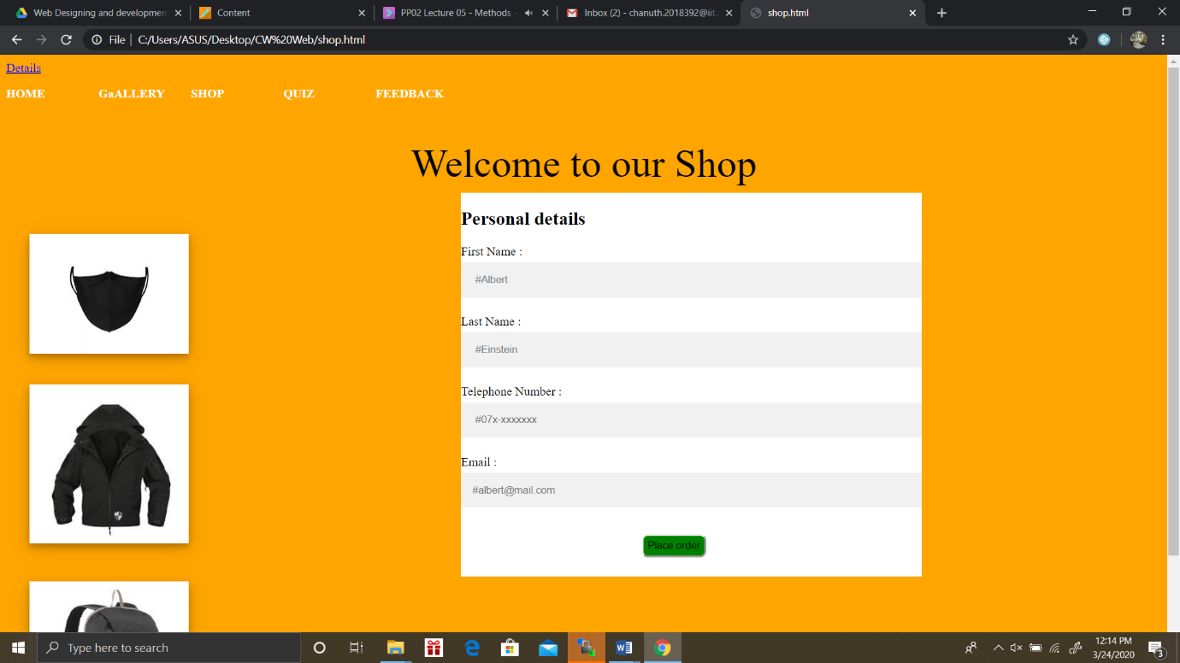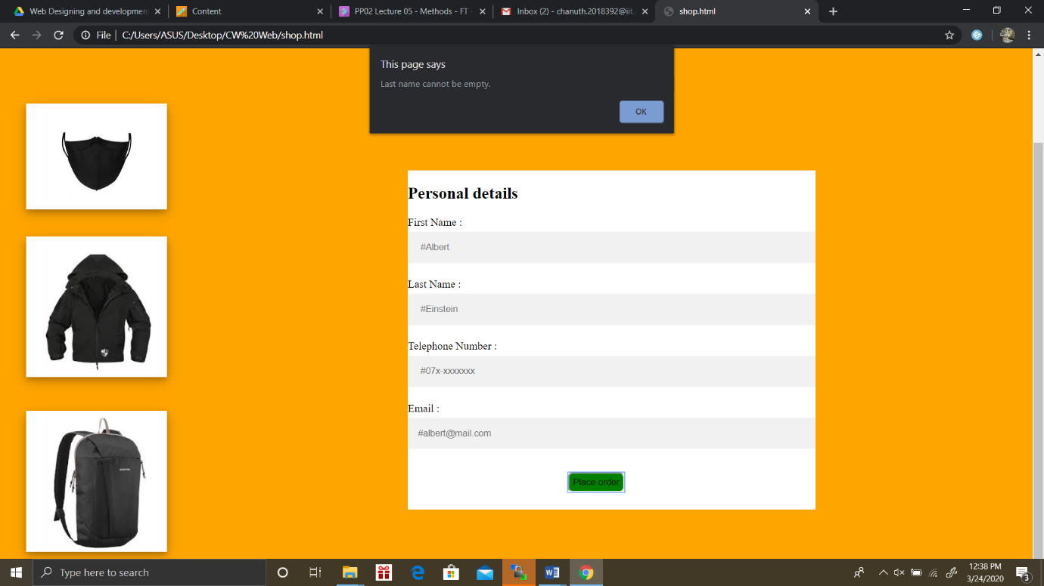

File Name

CV

Screenshot(s)



## Appendix C: Individual Statement

|  |  |  |  |
| --- | --- | --- | --- |
| Student Name: | Chanuth Wijesekara | Student Id: | 2018392 |
| State what tasks you carried out in the project. | | | |
| Student 1  Pages:- Presentation Page, Shopping cart page, Text Change, Article, Page Editor | | | |
| State what you enjoyed and did not enjoy about teamwork. | | | |
| I enjoyed because I got work to do and work as a team.  I didn’t enjoy because some information’s are not clear. | | | |
| State what you learnt about teamwork. | | | |
| I learned how to work fast and improved my team skills. | | | |
| State what skills you gained/learnt from undertaking the project. | | | |
| Communication Skill  Problem Solving | | | |
| State any strengths about yourself that emerged whilst undertaking the project. | | | |
| Team Spirit | | | |
| State any weaknesses about yourself that emerged whilst undertaking the project. | | | |
| Stress | | | |
| State how you would do things better if you were to undertake the project again. | | | |
| Start work early not at the last minute | | | |
| Additional general or project specific comments: | | | |
|  | | | |
| Student Signature: | Chanuth | Date: | 24th of March 2020 |